Name : SANCHITA KHETO
Department : PHILOSOPHY
Area of specialization : Vedanta
Permanent address : Vill:-Morhal, P.O:-Rajbalhat, P.S:-Jangipara, Pin:-712408
Phone no : 9734819297
Email id : sanchita.kheto@gmail.com
Date of birth : 07/05/1988
Nationality : Indian
Religion : Hindu
Gender : Female
Caste : General
Date of joining to the college: 21/08/2010
Designation: Gov. : STATE AIDED COLLEGE TEACHER
- Educational qualification :

Name of the exam. | Board/  Council/  University | Year of passing | % of marks
SECONDARY | WBBSE | 2003 | 66.87
HIGHER SECONDARY | WBCHE | 2005 | 64.3
B.A | BURDWAN | 2008 | 67.12
M.A | JADAVPUR | 2010 | 65.75
M. Phil | JADAVPUR | 2012 | PHILOSOPHY:(VAKTI-YOGA according to srimadbhagavadgita)
List of publication : 1 (EDULIGHT journal ,volume 7, Issue13,may,2018 ISSN:2278-9545)

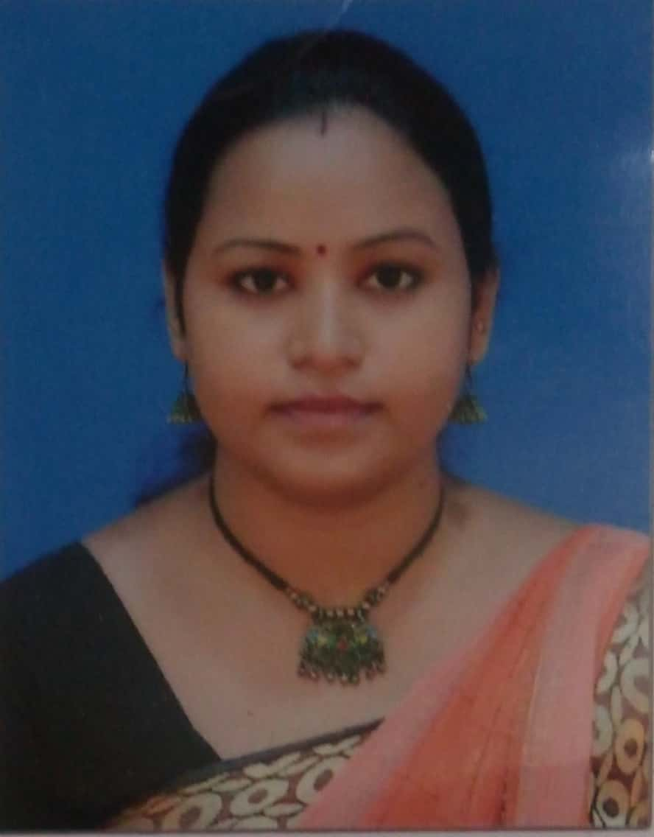
SANCHITA KHETO
I declare that the particulars given above are correct to the best of my knowledge and belief

